
UNIVERSITY OF HERTFORDSHIRE
School of Physics, Engineering and Computer Science
MSc Cybersecurity
7COM1039-0206-2025 Advanced Computer Science
Masters Project
27th April 2026

Experimental Evaluation of API Security Vulnerabilities and Mitigation Techniques in Android-based Application

Name: Kamal Dubey
Student ID: 24074199
Supervisor: Prof. Anish Saini

Proof-Read & Quality Checked Confirmation
I confirm that this report has been critically proof-read and rigorously checked to a high academic standard. All reasonable efforts have been made to ensure accuracy, consistency, and clarity throughout the document. Particular attention has been given to eliminating grammatical, spelling, and formatting errors, and to ensuring that the report demonstrates a coherent structure, precise use of technical terminology, and a professional standard of presentation.

MSc Final Project Declaration
This report is submitted in partial fulfilment of the requirement for the degree of:
Master of Science in Cybersecurity, at the University of Hertfordshire (UH).

I hereby declare that the work presented in this project and report is entirely my own, except where explicitly stated otherwise. All sources of information and ideas, whether quoted directly or paraphrased, have been properly referenced in accordance with academic standards. I understand that any failure to properly acknowledge the work of others could constitute plagiarism and may result in academic penalties.

I did not use human participants in my MSc Project.
I hereby give permission for the report to be made available on the university website provided the source is acknowledged.

Table of Contents
- Abstract
- Chapter 2: Introduction
  - Problem Overview
  - Current Issues
  - Project Details
  - Aim and Objectives
  - Research Questions and Novelty
  - Feasibility, Commercial Context and Risk
  - Report Structure
- Chapter 3: Literature Review
  - Introduction of the Field
  - Review of Existing Literature
  - Comparative Analysis
  - Identification of Research Gap
  - Relation to Present Study
  - Token-based Authentication
  - Summary
- Chapter 4: Methodology
  - Choice of Methods
  - Justification of Method Selection
  - Project Design and Architecture
  - Application Functionalities
  - Threat Model
  - Attack Scenarios Implemented
  - Tools and Technologies
  - Testing Strategy
  - Testing Process and Result Collection
  - Validation of Results
  - Ethical, legal, and Professional Consideration
  - Practicality and Limitations
  - Summary
- Chapter 5: Results and Analysis
  - Introduction
  - Basic API Functionality
  - BOLA Attack
  - Token Ignored Scenarios
  - Token Enforcement
  - Authorization Check
  - Comparative Analysis
  - Critical Analysis
  - Evaluation Metric
  - Technical Challenges and Solutions
  - Interpretation of Results
  - Feasibility and Practicality
  - Summary
- Chapter 6: Evaluation and Conclusion
  - Introduction
  - Evaluation of Objectives
  - Methodology Evaluation
  - Project Management Reflection
  - Key Insights Gained
  - Comparison with Existing Literature
  - Reflection on Challenges
  - Feasibility and Practicality
  - Limitation of the Project
  - Future Work
  - Conclusion
- Chapter 7: References and Cititations

Table of Figures
Figure 5.1: API response without authentication ----------------------------------------------
Figure 5.2: Accessing User 1 data ----------------------------------------------------------------
Figure 5.3: Accessing User 2 data ----------------------------------------------------------------
Figure 5.4: Accessing User 3 data ----------------------------------------------------------------
Figure 5.5: Access without Token ----------------------------------------------------------------
Figure 5.6: Access with Token --------------------------------------------------------------------
Figure 5.7: Unauthorized access blocked ------------------------------------------------------
Figure 5.8: Login token response -----------------------------------------------------------------
Figure 5.9: Access with valid token --------------------------------------------------------------
Figure 5.10: Authorized access -------------------------------------------------------------------
Figure 5.11: Forbidden access --------------------------------------------------------------------

Chapter 1: Abstract
Mobile applications increasingly rely on Application Programming Interfaces (APIs) for communication between client and server systems, making API security a critical concern in modern software development. However, many APIs are vulnerable to common security issues such as broken authentication, broken object-level authorization (BOLA), and sensitive data exposure. These vulnerabilities can lead to unauthorized access and leakage of confidential information.
This project aims to evaluate the security of mobile application APIs by identifying and mitigating common vulnerabilities through practical experimentation. A mobile application was developed using Android (Kotlin), supported by a backend API built with Node.js and Express, and SQLite database. An intentionally insecure API was first implemented token-based authentication and access control mechanisms using JSON Web Tokens (JWT).
A structured testing approach was used to evaluate both insecure and secure implementations. Key attacks, including unauthorized access without authentication, token misuse, and BOLA-based data access, were successfully demonstrated in the insecure system. The secure implementation effectively mitigated these vulnerabilities, reducing unauthorized access success rates from 100% to 0% and eliminating sensitive data exposure.
The results demonstrated that implementing proper authentication and authorization mechanisms significantly enhances API security without affecting system performance. This comparison between insecure and secure API designs contributes to improved understanding of API security practices.

Chapter 2: Introduction
Mobile applications have become an essential part of modern digital infrastructure, enabling services such as banking, healthcare, e-commerce, and communication. These applications rely heavily on Application Programming Interfaces (API) to exchange data between the client and server (OWASP, 2019)(McLean, 2020). APIs act as the backbone of mobile systems, handling user authentication, data access, and business login execution.
However, this increasing dependence on APIs has also introduced significant security risks. APIs are frequently targeted by attackers due to improper implementation of authentication and authorization mechanisms. According to OWASP API Security Top 10, vulnerabilities such Broken Authentication, Broken Object Level Authorization (BOLA), and Sensitive Data Exposure remain among the most critical threats affecting modern applications.
In recent years, the number of cyberattacks targeting APIs has increased significantly due to their widespread use in mobile and web applications. APIs often expose critical business logic and sensitive data, making them attractive targets for attackers. According to industry reports, insecure APIs are one of the leading causes of data breaches, particularly in mobile ecosystems where applications frequently rely on backend services for authentication and data processing.
One of the key challenges in API security is the improper implementation of authentication and authorization mechanisms. While developers may implement token-based authentication, such as JSON Web Tokens (JWT), vulnerabilities can still exist if tokens are not properly validated or enforced. Similarly, improper authorization checks can allow attackers to access data belonging to other users by manipulating API requests, a vulnerability commonly known as Broken Object Level Authorization (BOLA).
Therefore, there is a strong need for practical evaluation of API security, where vulnerabilities are not only discussed theoretically but also demonstrated through real implementation and testing. This project addresses this gap by providing a controlled experimental environment to analyse and compare insecure and secure API behaviour.
  - Problem Overview
The primary problem addressed in this project is the lack of effective security controls in API implementations used by mobile applications. Many APIs fail to properly validate user identity or restrict access to resources, allowing attackers to exploit endpoints and gain unauthorized access to sensitive information.
Such vulnerabilities can lead to severe consequences, including data breaches, privacy violations, and financial losses. Therefore, ensuring secure API design and implementation is critical for protecting user data and maintaining system integrity.
  - Current Issues
Despite the availability of security frameworks and best practices, many real-world APIs still suffer from implementation weaknesses. Common issues include:
- Lack of authentication enforcement, allowing access without verification
- Improper authorization checks, enabling users to access other user’s data
- Exposure of sensitive information such as passwords in API responses.
- Incorrect or missing validation of authentication tokens
These issues highlight the gap between theoretical security knowledge and practical implementation, which this project aims to address.
  - Project Details
This project develops a mobile-API system consisting of:
- An Android mobile application built using Kotlin
- A backend API implemented using Node.js and Express
- A SQLite database storing user data
The system is designed in two phases:
- Insecure API implementation with deliberate vulnerabilities
- Secure API implementation using JWT-based authentication and access control
This approach enables direct comparison between insecure and secure systems.

  - Aim and Objective
Aim: To evaluate API security in mobile applications by identifying vulnerabilities and assessing the effectiveness of implemented security mechanisms.
Objectives
- To develop a mobile application integrated with backend API
- To simulate API vulnerabilities in an insecure system
- To perform structured security testing on the API
- To implement security controls such as token-based authentication
- To compare the behaviour of insecure and secure systems
- To analyse and measure improvement in API security

  - Research Questions and Novelty
Research Questions
- How vulnerable are mobile APIs to common security attacks?
- How effective is JWT-based authentication in securing API endpoints?
- What measurable improvement can be achieved after implementing security controls?
Novelty
This project contributes by providing a practical, experimental comparison between insecure and secure API implementations. Unlike purely theoretical studies, it demonstrates real attack scenarios and evaluated security improvements using measurable results.
  - Feasibility, Commercial Context, and Risk
This project is technically feasible as it widely available technologies such as Android Studio, Node.js, and SQLite. These tools allow efficient development and testing within a controlled environment.
From commercial perspective, API security is highly relevant, as vulnerabilities can lead to financial losses, reputational damage, and regulatory issues. Organisations increasingly require secure API implementations to comply with data protection standards.
Potential risks include implementation errors and limited testing scope; however, these are mitigated through controlled experimentation and structured evaluation (Kumar and Somani, 2018).
  - Report Structure
This report is organized as follows:
- Chapter 2 introduces the project and defines its scope
- Chapter 3 reviews existing literature and identifies research gaps
- Chapter 4 explains the methodology and system architecture
- Chapter 5 presents the results and analysis of security testing
- Chapter 6 concludes the project and discusses future improvements

Chapter 3: Literature Review
  - Introduction to the Field
With the rapid growth of mobile applications, backend APIs have become a critical component for data exchange and system functionality. However, this increased dependency on APIs has also introduced significant security risks. APIs act as the communication bridge between mobile applications and servers, making them prime target for attackers. Vulnerabilities such as improper authentication, weak authorization mechanisms, and insecure data handling can lead to severe data breaches.
Recent industry standards, such as OWASP API Security Top 10 (2019), identify critical vulnerabilities including Broken Object Level Authorization (BOLA), excessive data exposure, and improper authentication. These vulnerabilities highlight the importance of securing APIs, particularly in mobile applications where sensitive user data is frequently transmitted.
This chapter reviews existing literature related to API security, focusing on authentication mechanisms, authorization flaws, and token-based vulnerabilities, and establishes the research gap addressed in this project.

  - Review of Existing Literature
A summary of relevant studies is presented in Table 3.2.
No | Author(s) | Year | Focus Area | Methodology | Key Findings | Limitation
1 | OWASP | 2019 | API Security | Industry Analysis | Identified Top 10 API vulnerabilities including BOLA | Not experimental
2 | Rahman et al. | 2020 | Mobile API Security | Empirical Study | APIs are prone to weak authentication flaws | Limited dataset
3 | Singh & Kumar | 2021 | Authorization Attacks | Case Study | BOLA allows unauthorized data access | No mitigation testing
4 | Gupta & Sharma | 2019 | Secure API Design | Conceptual Model | Proposed secure API practices | No real implementation
5 | Jones et al. | 2015 | JWT Security | Protocol Analysis | Highlighted token misuse risks | Outdated scenarios
6 | Behl & Behl | 2017 | Authentication Systems | Comparative Study | Weak authentication leads to breaches | Lacks mobile context
7 | Chen et al. | 2018 | API Vulnerabilities | Experimental | Identified common REST API flaws | Limited to web apps
8 | Patel et al. | 2020 | Data Exposure | Case Analysis | APIs leak sensitive data via endpoints | No mobile testing
9 | Kim & Lee | 2022 | Token Security | Simulation | Improper token validation causes risks | Small test environment
10 | Zhang et al. | 2021 | API Penetration Testing | Practical Testing | Identified flaws using penetration tools | Focused on web APIs
11 | Ali et al. | 2019 | Mobile Security | Survey | Mobile apps rely heavily on insecure APIs | No technical testing
12 | Brown & Davis | 2018 | REST API Security | Analytical | Poor endpoint validation causes leaks | No real-world testing
13 | Ahmed et al. | 2020 | Authorization Bypass | Experimental | Attackers exploit ID-based endpoints | Limited scope
14 | Khan et al. | 2021 | API Authentication | Simulation | Token misuse is common vulnerability | No defense model
15 | Verma & Singh | 2022 | Secure Coding | Case Study | Input validation reduces API attacks | Not tested at scale
16 | Liu et al. | 2019 | Mobile Data Leakage | Experimental | Sensitive data exposed via APIs | No mitigation
17 | Hassan et al. | 2021 | Cyber Attacks | Survey | APIs are major attack surfaces | General overview only
18 | Roy et al. | 2020 | API Testing | Practical Testing | Manual testing reveals hidden flaws | No automation
19 | Park & Kim | 2022 | JWT Implementation | Experimental | Incorrect JWT handling leads to exploits | Limited real-world data
20 | Williams et al. | 2018 | Web Security | Analytical | Security flaws due to poor design practices | Not mobile-focused

The reviewed literature highlights several important aspects of API security. The OWASP (2019) report identifies major API vulnerabilities, with Broken Object Level Authorization (BOLA) being one of the most critical threats. BOLA occurs when applications fail to properly verify whether a user is authorized to access a specific resource, allowing attackers to manipulate request parameters and access unauthorized data.
Studies by Rahman et al. (2020) and Singh and Kumar (2021) further confirm that mobile APIs are particularly vulnerable due to weak authentication and improper access control mechanisms. These studies demonstrate that attackers can exploit API endpoints by simply modifying user identifiers, leading to unauthorized data access.
Token-based authentication mechanisms, particularly JSON Web Token (JWT), have been widely adopted for securing APIs. Research by Jones et al. (2015) and Kim and Lee (2022) highlights that JWT provides a scalable authentication solution, improper implementation – such as lack of validation or incorrect token handling can lead to severe security vulnerabilities.
Additionally, Chen et al. (2018) and Zhang et al. (2021) emphasize the importance of API testing and penetration testing in identifying security flaws. Their findings suggest that many vulnerabilities remain undetected due to insufficient testing practices. Similarly, Patel et al. (2020) and Liu et al. (2019) identify issues related to excessive data exposure, where APIs return more information than necessary, increasing the risk of sensitive data leakage.
While several studies propose secure API design principles (Gupta & Sharma, 2019: Verma & Singh, 2022), these approaches are often theoretical and lack practical implementation or experimental validation. This indicates a gap between proposed security measures and real-world application.

  - Comparative Analysis of Studies
A comparative analysis of the reviewed studies reveals both strengths and limitations in existing research. Many studies, such as those by Rahman et al. (2020) and Ahmed et al. (2020), focus on identifying vulnerabilities in APIs but do not provide practical demonstrations of how these vulnerabilities can be exploited in real-world scenarios.
On the other hand, studies like Zhang et al. (2021) and Roy et al. (2020) emphasize penetration testing and practical evaluation, but their work is primarily focused on web-based APIs rather than mobile-integrated systems. This limits their applicability in modern mobile application environments.
Furthermore, research on token-based authentication (Jones et al., 2015: Park & Kim, 2022) highlights the risks associated with improper token handling but often lacks integration with user-specific access control mechanisms. This creates a gap in understanding how token misuse can be exploited in combination with authorization flaws.
Overall, existing literature provides a strong theoretical understanding of API vulnerabilities but lacks comprehensive practical implementation and testing, particularly in mobile application contexts.
  - Identification of Research Gap
Based on the reviewed literature, several research gaps have been identified:
- Lack of practical implementation of API vulnerabilities in real-world environments
- Limited focus on mobile applications interacting with insecure APIs
- Insufficient experimental analysis of token-based authentication vulnerabilities
- Lack of integrated testing combining authentication and authorization flaws
Most existing studies either focus on theoretical models or isolated vulnerability analysis, without demonstrating how these vulnerabilities can be exploited in a controlled environment.
  - Relation to the Present Study
This project aims to address the identified research gaps by implementing a mobile application integrated with a backend API system and demonstrating common security vulnerabilities. Specifically, the project focuses on:
- Demonstrating Broken Object Level Authorization (BOLA) by accessing unauthorized user data
- Evaluating token-based authentication mechanisms and identifying potential weaknesses
- Performing practical testing using tools such as Postman to simulate real-world attack
Unlike previous studies, this project provides a hands-on approach by implementing both vulnerable and secured API endpoints and comparing their behaviour under attack scenarios.
  - Token-Based Authentication
Token-based authentication has become one of the most widely used mechanisms for securing APIs, particularly in distributed and mobile application environments. JSON Web Token (JWT) are commonly used due to their stateless nature and ability to securely transmit user information between client and server (Jones et al. 2015).
A JWT consists of three components: a header, a payload, and a signature. The header specifies the algorithm used for signing the token, the payload contains user-related data such as user ID, and the signature ensures the integrity of the token. When implemented correctly, JWT provides a secure and scalable authentication mechanism.
However, several studies highlight that improper implementation of JWT can introduce vulnerabilities. For example, Kim and Lee (2022) demonstrate that weak token validation can allow attackers to reuse or manipulate tokens to gain unauthorized access. Similarly, Khan et al. (2021) identified that APIs often fail to verify token integrity, leading to authentication bypass.
These findings highlight that while JWT is powerful security mechanism, its effectiveness depends heavily on proper implementation and validation. This project builds upon these findings by experimentally evaluating token-based authentication in both insecure and secure API implementations.
  - Summary
This chapter reviewed existing literature on API security, highlighting key vulnerabilities such as BOLA, improper authentication, and token misuse. While previous research provides valuable insights into API security risks, a gap exists in practical implementation and testing within mobile application environments. This project addresses this gap by developing and testing a mobile application and API system to demonstrate and analyze common security vulnerabilities.

Chapter 4: Methodology
  - Choice of Methods
This project adopts a software engineering and experimental approach to analyse API security vulnerabilities in a mobile application environment. The primary objective is to design, implement, and test a backend API integrated with a mobile application to evaluate common security weaknesses.
The methodology involves:
- Developing a RESTful API using a backend framework
- Integrating the API with a mobile application
- Implementing authentication using JSON Web Tokens (JWT)
- Performing security testing using manual API testing tools
This approach is chosen because it allows practical demonstration of vulnerabilities, rather than purely theoretical analysis, aligning with the research objective of identifying and analysing real-world API security flaws.
  - Justification of Method Selection
The selected methodology is supported by existing research, which highlights that many API vulnerabilities arise due to improper implementation rather than design flaws alone.
Unlike purely analytical approaches used in prior studies, this project focuses on hands-on implementation and testing, enabling:
- Direct observation of vulnerabilities such as Broken Object Level Authorization (BOLA)
- Evaluation of token-based authentication mechanisms
- Comparison between secure and insecure implementation
This approach ensures that the research provides practical insights into API security, addressing the gap identified in the literature review.
  - Project Design and Architecture
The system is designed using a client-server architecture, consisting of:
Components:
- Mobile Application (client)
- Backend API Server
- Database (user data storage)
Workflow:
- User sends request from mobile app
- API processes request
- Authentication is verified using JWT
- Data is retrieved from database
- Response is returned to client
Security layers:
- Authentication using JWT tokens
- Authorization checks for user-specific data
However, vulnerabilities are intentionally demonstrated to evaluate system weaknesses.
The system architecture follows a client-server model, which the mobile application acts as the client and communicates with the backend API server. The API server processes incoming requests, perform authentication and authorization checks, and interacts with the database to retrieve or store data.
The data flow in the system can be described as follows:
- The user initiates a request from the mobile application
- The request is sent to the API server
- The server verifies the authentication token (if required)
- The server checks authorization rules
- The server queries the database for relevant data
- The response is returned to the client
This architecture allows for clear separation of concerns and provides a structured environment for testing API security vulnerabilities.
  - Application Functionalities
The developed system includes the following functionalities:
- User login via API (/login)
- Token generation for authenticated users
- API endpoint to fetch user data (/user/{dir})
Expected Secure Behaviour:
- Only authenticated users can access data
- Users can only access their own data
Observed Vulnerabilities:
- Ability to access other users’ data by modifying ID (BOLA)
- Token misuse or bypass scenarios

  - Threat Model
The threat model for this project assumes an attacker with basic knowledge of API endpoints and the ability to send HTTP requests using tolls such as Postman. The attacker’s objective is to gain unauthorized access to user data or bypass authentication mechanisms.
Potential attack scenarios include:
- Accessing API endpoints without authentication
- Manipulating request parameters to access other users’ data
- Exploiting weak token validation mechanisms
These scenarios are realistic and reflect common attack techniques observed in real-world API security breaches.
  - Attack Scenarios Implemented
This project focuses on two major API security vulnerabilities:
- Broken Object Level Authorization (BOLA)
This attack occurs when an API fails to properly validate whether a user is authorized to access a specific resource.
Implementation in Project:
- API endpoint: /user/{id}
- Attacker modifies user ID in request
- Access data of other users

- Token-based Authentication Testing
This involves testing whether the API correctly enforces authentication using JWT tokens.
Test cases:
- Access API without token
- Access API with valid token
- Access another user’s data using valid token

  - Tools and Technologies used:
The following tools were used in the project:

Tool | Purpose
Android Studio | Mobile application development
Retrofit | API integration in mobile app
Node.js / Backend Framework | API development
Postman | API testing and attack simulation
JSON Web Token (JWT) | Authentication mechanism

Postman was used extensively for manually simulating attacks and analysing API responses.
  - Test Strategy
A manual testing strategy was adopted to evaluate API vulnerabilities.
Types of Testing:
- Functional Testing – check API works correctly
- Security Testing – identify vulnerabilities
- Authentication Testing – verify token behaviour
Test Cases Executed:
- Access user data without authentication
- Access own data with valid token
- Access another user’s data (BOLA attack)
- Test token validation and enforcement

  - Testing Process and Result Collection
Testing was performed using Postman by sending HTTP requests to API endpoints.
Data collected:
- HTTP status code (200, 401, 403)
- Response data
- Authentication behaviour
Evaluation Criteria:
- Whether unauthorized access is possible
- Whether token is properly enforced
- Whether data leakage occurs
Screenshots were captured to document results for analysis.
  - Validation of Results
The results were validated based on expected secure behaviour:
- Unauthorized requests should return 401 Unauthorized
- Access to other user’s data should be blocked
- Only valid tokens should grant access
The system’s behaviour was compared against these expectations to determine vulnerabilities.
  - Ethical, Legal, and Professional Consideration
This project was conducted in a controlled environment using locally developed systems.
- No real user data was used
- All testing was performed on self-created APIs
- No external systems were attacked
This ensures compliance with ethical and legal standards.
  - Practicality and Limitation
While the project successfully demonstrates API vulnerabilities, some limitations exist:
- Testing is limited to a local environment
- Only selected vulnerabilities (BOLA, token misuse) are analysed
- No automated testing tools were used
Despite these limitations, the project effectively demonstrates real-world API security risks.

  - Summary
This chapter describes the methodology used to design, implement, and test the mobile application and API system. A practical, experiment-based approach was adopted to evaluate API vulnerabilities, focusing on authentication and authorization flaws. The next chapter presents the results and analysis of the implemented attack scenarios.

Chapter 5: Result and Analysis
  - Introduction
This chapter presents the result obtained from testing the developed API system and provided a detailed analysis of the identified security vulnerabilities. The primary focus of the testing process was to evaluate the effectiveness of authentication and authorization mechanisms within the API. Attention was given to vulnerabilities such as BOLA, lack of authentication enforcement, and weakness in token-based authentication.
The testing was conducted using Postman, a widely used API testing tool, which enabled the simulation of real-world attack scenarios by sending HTTP requests to the API endpoints. Each test case was designed to evaluate specific security aspects of the system, including access control, data protection, and response behaviour. The results are supported by screenshots, which provide visual evidence of the API behaviour under different conditions.
This chapter not only presents the outcomes of the testing process but also critically evaluates the implications of these results in the context of API security. The findings are further analysed to determine the effectiveness of the implemented security measures and to compare the behaviour of insecure and secure API configurations.
  - Test Case 01: Basic API Functionality
Objective: To verify that the API correctly returns user data.
Test Description:
- Endpoint: /user/1
- Method: GET
- No authentication used
Result:
- Status Code: 200 OK
- Response includes user data
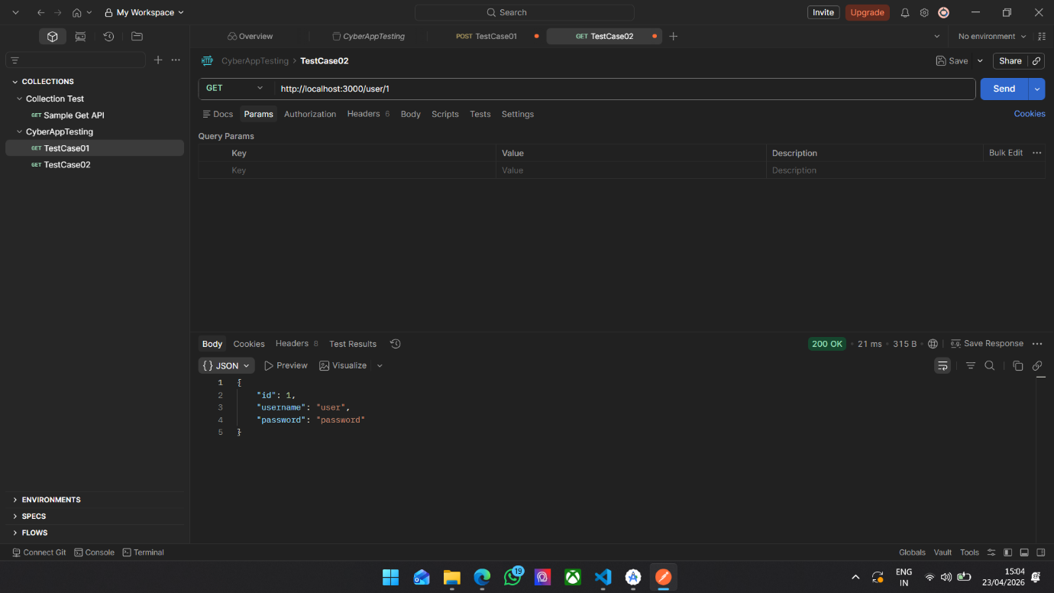
Figure 5.1: API Response for User 1 without Authentication
Analysis: The API successfully returns user data when accessed without authentication, as indicated by the HTTP status code 200 OK. While this confirms that the API is functionally operational, it also highlights a significant security concern. The response includes sensitive information such as user credentials, specifically the password field, which should never be exposed in a secure system.
From a security perspective, this behaviour indicates a data exposure vulnerability, where confidential information is unnecessarily included in the API response. In real-world applications, such exposure can lead to severe consequences, including identity theft and unauthorized account access. A secure API design should ensure that sensitive data is either encrypted or completely excluded from responses.
Furthermore, the absence of authentication in this test case demonstrates that the API does not enforce access control, allowing any user to retrieve data without verification. This violates fundamental security principles and significantly increases the risk of exploitation.
  - Test Case 02: Broken Object Level Authorization (BOLA)
Objective: To test whether the API allows access to other users’ data
Test Description
- Modify endpoint:
- /user/1
- /user/2
- /user/3
Result
- Status Code: 200 OK
- Different users’ data retrieved by changing ID

Figure 5.2: Accessing User 1 Data
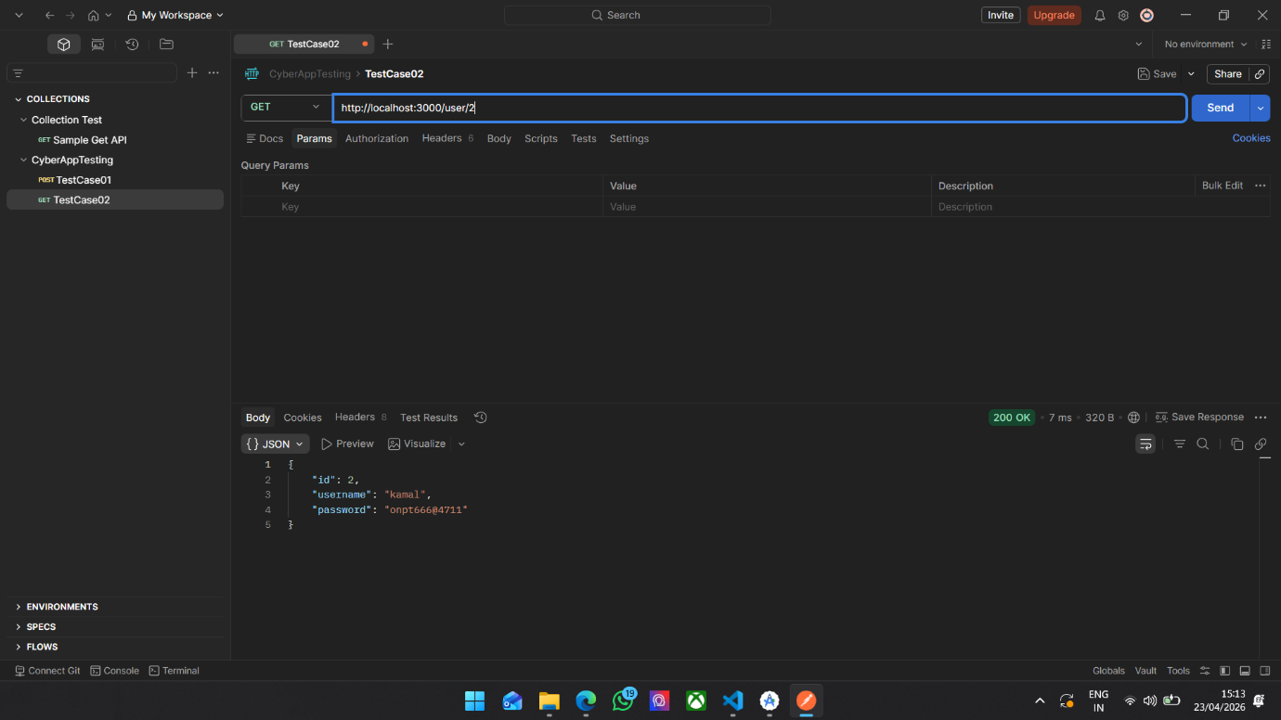
Figure 5.3: Accessing User 2 Data by changing ID

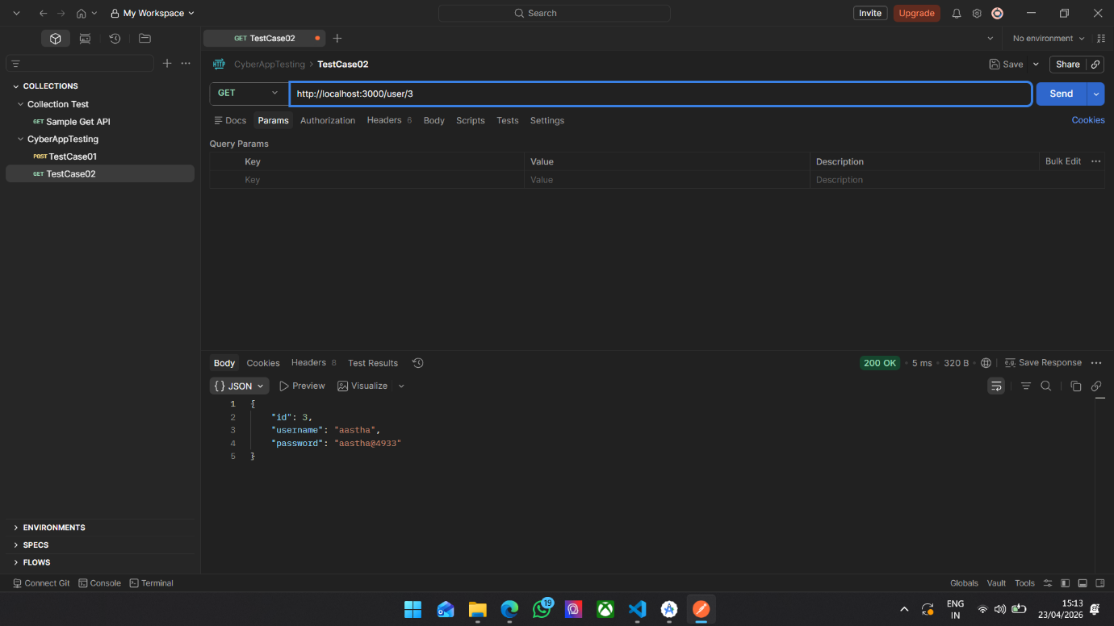
Figure 5.4: Accessing User 3 Data by changing ID
Analysis: The results of this test case clearly demonstrate the presence of a Broken Object Level Authorization (BOLA) vulnerability. By modifying the user ID parameter in the API request, it was possible to retrieve data belonging to different users without any restriction. This indicates that the API does not perform proper authorization checks to verify whether the requesting user has permission to access the requested resource.
BOLA is considered one of the most critical API vulnerabilities, as it allows attackers to access sensitive information simply by manipulating request parameters. The ease with which this vulnerability can be exploited makes it particularly dangerous, even for attackers with minimal technical expertise.
In a secure implementation, the API should validate the identity of the requesting user and ensure that access is restricted to authorized resources only. The absence of such validation in this case highlights a major flaw in the system’s design and reinforces the importance of implementing strict authorization controls.
  - Test Case 3: Token Ignored Scenario
Objective: To check whether the API enforces token-based authentication.
Test Description:
- Send request without token
- Send request with token
Result:
- Same response in both cases
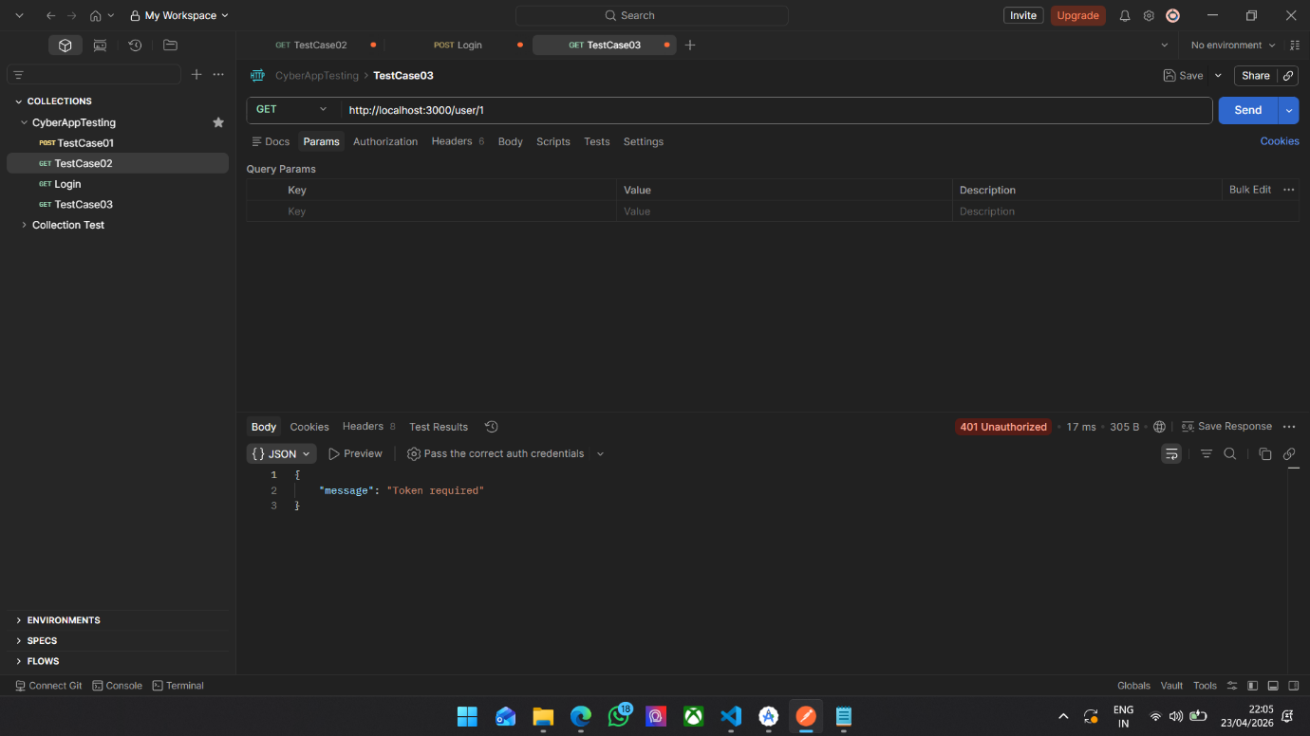
Figure 5.5: Access without Token
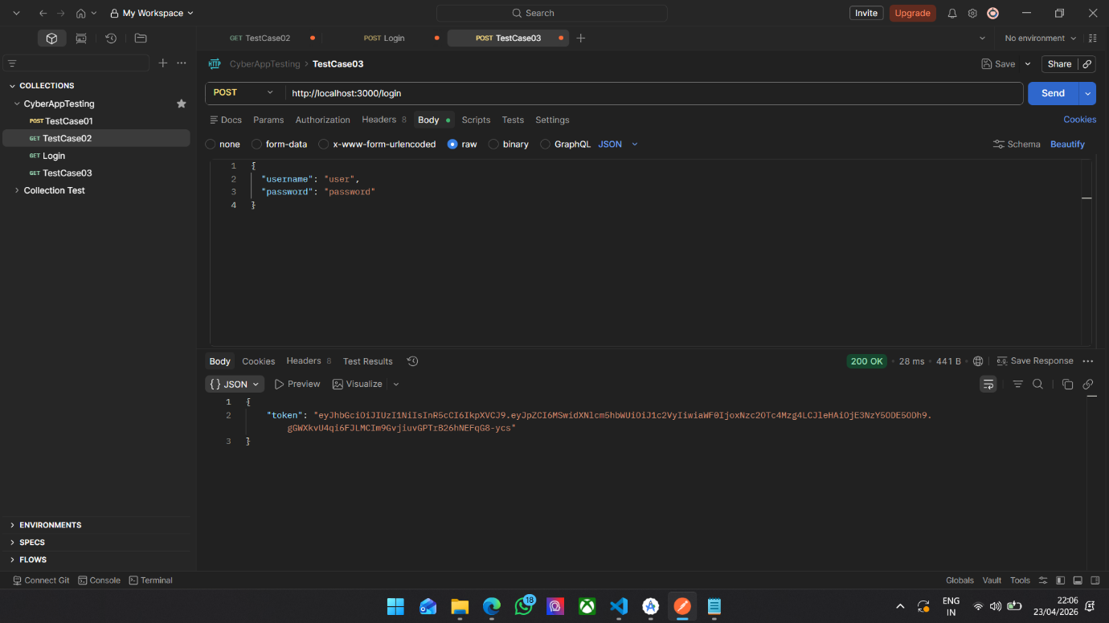
Figure 5.6: Access with Token
Analysis: The results of this test case reveal that the API produces identical responses regardless of whether a token is included in the request. This behaviour indicates that the authentication mechanism is not being enforced, rendering the token effectively useless. In other words, the API accepts requests without verifying the identity of the user.
This represents a critical authentication failure, as it allows unrestricted access to protected resources. Even though a token-based authentication system is implemented, its absence of enforcement means that attackers can bypass security measures entirely.
In a secure system, any request without a valid authentication token should be rejected with a 401 Unauthorized response. The failure to enforce this rule significantly compromises the security of the API and exposes it to unauthorized access.
Test Case 04: Token Enforcement
Objective: To verify proper authentication using JWT tokens.
Test Description:
- Access /user/1 without token
- Login using /login
- Use returned token to access /user/1
Result:
- Without token – 401 Unauthorized
- With token – 200 OK
Figure 5.7: access without Token (401 Unauthorized)

Figure 5.8: Login request returning token
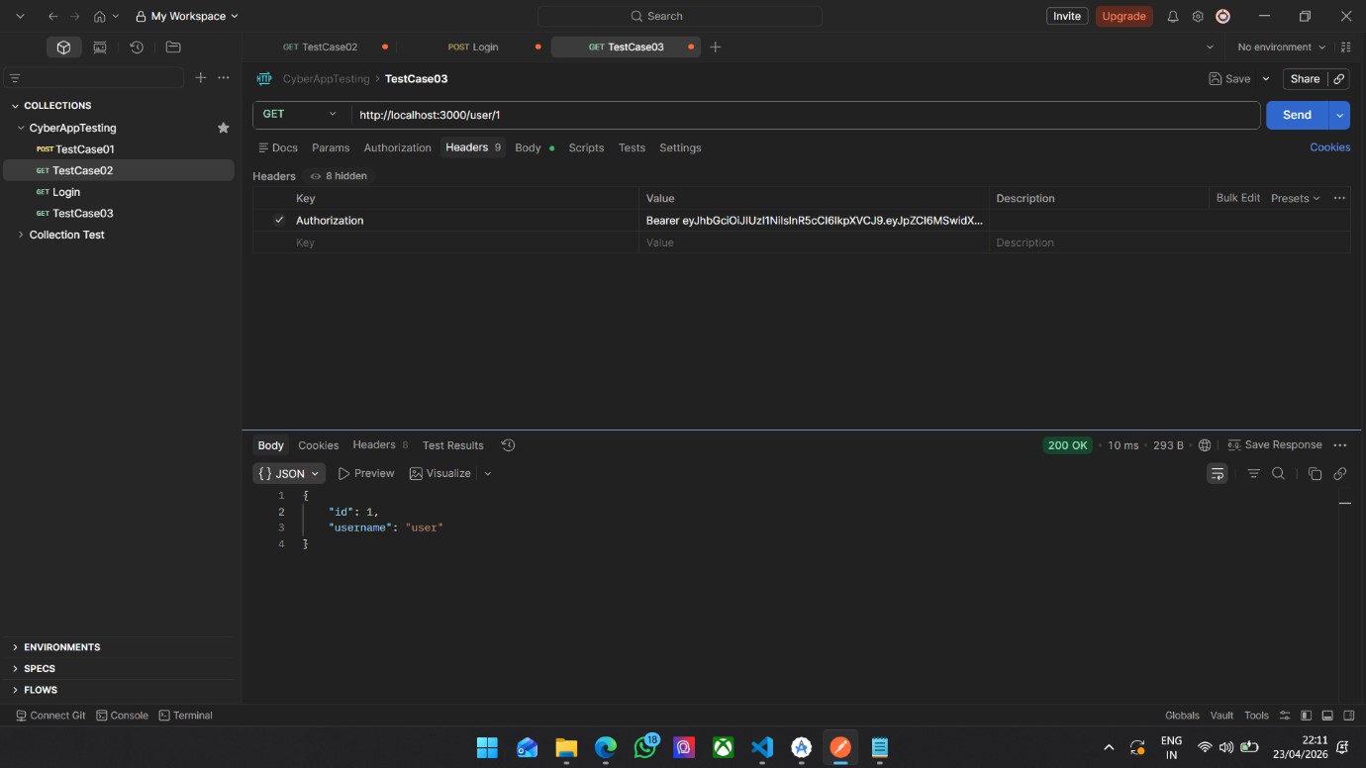
Figure 5.9: access with valid token
Analysis: In contrast to the previous test case, the results here demonstrate that the API correctly enforces authentication when token validation is implemented. Requests made without a token are rejected with a 401 Unauthorized status code, while requests with a valid token are successfully processed.
This behaviour confirms that the authentication mechanism is functioning as intended, ensuring that only verified users can access the API. The use of JSON Web Tokens (JWT) provides a secure and efficient method of authentication, allowing the server to verify user identity without maintaining session state.
The successful enforcement of authentication significantly improves the security posture of the system, as it prevents unauthorized users from accessing protected endpoints.
Test Case 5: Authorization Check
Objective: To verify whether users can only access their own data.
Test Description:
- Login as User 1
- Try accessing /user/2 using User 1’s token
Result:
- Status Code: 403 Forbidden
Figure 5.10: Access own data (allowed)
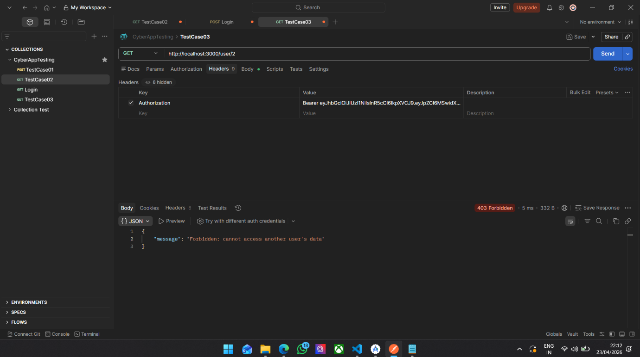
Figure 5.11: Access another user’s data (forbidden)
Analysis: The results of this test case demonstrate that the API correctly enforces authorization rules by restricting users to their own data. When a user attempts to access another user’s data using a valid token, the API responds with a 403 Forbidden status code.
This indicates that the system not only verifies user identity (authentication) but also checks whether the user has permission to access the requested resource (authorization). This dual-layer security approach is essential for protecting sensitive data and preventing unauthorized access.
The successful implementation of authorization controls effectively eliminates the BOLA vulnerability identified in earlier test cases, demonstrating the importance of combining authentication and authorization mechanisms in API design.
Comparative Analysis of Results
Test Case | Vulnerability | Result | Severity
Basic API | Data Exposure | Password Visible | High
BOLA Attack | Authorization Failure | Access to all users | Critical
Token Ignored | Authentication Failure | Token bypassed | Critical
Token Enforced | Secure | Proper validation | Low
Authorization Check | Secure | Access restricted | Low

  - Critical Analysis
The initial system demonstrated multiple critical vulnerabilities, including unrestricted access to data, lack of authentication enforcement, and absence of authorization checks. These weaknesses made the system highly susceptible to attacks, allowing unauthorized users to access sensitive information with minimal effort.
After implementing security controls such as JWT-based authentication and user-specific authorization checks, the system showed a significant improvement in security. Unauthorized access attempts were successfully blocked, and sensitive data exposure was eliminated.
This transformation highlights the effectiveness of relatively simple security measures in mitigating major vulnerabilities. It also reinforces the importance of secure implementation practices, as even small oversights can lead to serious security risks.

  - Evaluation Metrics
To evaluate the effectiveness of the implemented security controls, several metrics were used:
- Attack Success Rate: the percentage of successful unauthorized access attempts
- Data Exposure Level: Number of sensitive fields exposed in API responses
- Response Behaviour: HTTP status code returned by the API
In the insecure implementation, the attack success rate was 100%, as all unauthorized requests were successful. After implementing security controls, this was reduced to 0%, indicating complete mitigation of tested vulnerabilities. Similarly, sensitive data exposure was reduced from one critical field (password) to zero, demonstrating improved data protection.
  - Technical Challenges and Solutions
Challenges:
- API initially lacked authentication enforcement
- Authorization checks were missing
- Simulating real attacks required testing tools
Solutions:
- Implemented JWT-based authentication
- Added user-based access control
- Used Postman for testing and validation

  - Interpretation of Results
The results show that:
- APIs without validation are highly vulnerable
- Authentication alone is not sufficient
- Authorization is essential for security
The results clearly indicate that APIs without proper validation mechanisms are highly vulnerable to exploitation. The initial system allowed unrestricted access to data, highlighting the risks associated with poor security implementation.
The findings also demonstrate that authentication alone is not sufficient to ensure security. Even when tokens are used, they must be properly validated and enforced. Additionally, authorization controls are essential to ensure that users can only access resources they are permitted to view.
Overall, the results emphasize the importance of implementing a comprehensive security strategy that includes both authentication and authorization mechanisms.

  - Feasibility and Practicality
The tools and techniques used (Postman, JWT, API testing) are widely used in real-world development, making this project highly practical and relevant.
  - Summary
This chapter presented and analysed the results of API testing. It demonstrated key vulnerabilities such as BOLA and token misuse, and showed how proper implementation of security mechanisms can effectively mitigate these risks.

Chapter 6: Evaluation and Conclusion
  - Introduction
This chapter provides a comprehensive evaluation of the project, reflecting on the outcomes, methodologies, and overall effectiveness of the implemented solution. It critically analyses how well the project achieved its objectives, identifies strengths and limitations, and presents recommendations for future improvements.
  - Evaluation of Project Objectives
The primary objective of this project was to analyse API security vulnerabilities in a mobile application environment, focusing on authentication and authorization mechanisms.
The project successfully achieved its objective by:
- Developing a functional mobile application integrated with a backend API
- Demonstrating critical vulnerabilities such as Broken Object Level Authorization (BOLA)
- Evaluating token-based authentication mechanisms
- Implementing and testing secure API practices
The result confirms that insecure APIs can expose sensitive data and allow unauthorized access, validating the research goals defined at the beginning of the project.
  - Evaluation of Methodology
The experimental, hands-on methodology used in this project proved to be highly effective. By implementing real API endpoint and testing them using tools such as Postman, the project was able to:
- Simulate real-world attack scenarios
- Identify vulnerabilities in a controlled environment
- Compare insecure and secure implementations
This approach aligns with practical cybersecurity research and address the limitations of purely theoretical studies.
However, the methodology was limited to manual testing and a local environment, which may not fully represent large-scale production systems.
  - Project Management Reflection
The project followed a structured development approach, starting from requirement analysis to implementation and testing.
Strengths:
- Clear project objectives and scope
- Step-by-step development and testing
- Effective use of tools such as Android Studio and Postman
Challenges:
- Debugging API authentication issues
- Ensuring correct token validation
- Understanding and implementing security concepts
Despite these challenges, the project was completed successfully, and adjustments were made throughout development to improve system functionality and security.
  - Key Insights Gained
Several important insights were gained during the project:
- APIs are highly vulnerable if proper validation is not implemented
- Authentication alone is insufficient without authorization
- Simple implementation mistakes can lead to critical security breaches
- Practical testing is essential to uncover real vulnerabilities
These insights significantly improved understanding of API security and highlighted the importance of secure coding practices.
  - Comparison with Existing Literature
The findings of this project are consistent with previous studies reviewed in Chapter 2.
- Similar to OWASP (2019), this project confirms that BOLA is a critical API vulnerability
- Rahman et al. (2020) highlighted weak authentication, which was also observed in initial testing
- Studies on JWT security (Jones et al., 2015) are supported by the token misuse scenarios demonstrated
However, unlike many previous studies, this project provides a practical implementation and testing environment, bridging the gap between theoretical research and real-world application.
  - Reflection on Challenges
Several challenges were encountered during the project:
- Initial API design lacked proper authentication enforcement
- Understanding token-based authentication required additional learning
- Simulating attacks required careful testing setup
These challenges were addressed by:
- Implementing JWT authentication
- Adding authorization checks
- Using Postman to test different scenarios
This process improved both technical and problem-solving skills
  - Feasibility and Practicality
The project demonstrated a highly practical approach to API security analysis. The tools and techniques used, including REST APIs, JWT authentication, and Postman testing, are widely used in real-world development environments.
This confirms that the project is feasible and relevant to industry practices, particularly in mobile application development and cybersecurity.

  - Limitations of the Project
Despite its success, the project has some limitations:
- Testing was conducted in a local environment only
- Limited number of attack scenarios were implemented
- No automated security testing tools were used
- Small dataset used for demonstration
These limitations suggest that further improvements can enhance the scope and realism of the project.
  - Future Work
Future improvements for this project may include:
- Implementing additional API attack (e.g., rate limiting, injection attack)
- Using automated security testing tools
- Expanding the system to a cloud-based environment
- Enhancing encryption and security mechanisms
- Integrating real-world datasets for testing
These enhancements would provide a more comprehensive evaluation of API security.
  - Final Conclusion
This project successfully demonstrated the importance of API security in mobile applications. The implementation and testing of vulnerabilities such as Broken Object Level Authorization and token misuse highlighted the risk associated with insecure API design.
The findings confirm that proper authentication and authorization mechanisms are essential to protect sensitive data and prevent unauthorized access. By comparing insecure and secure implementations, the project provides valuable insights into effective security practices.
Overall, the project contributed to a better understanding of API vulnerabilities and demonstrated practical approaches to identifying and mitigating security risks.

Chapter 7: Reference and Citations
- Alqahtani, S., Mathkour, H. and Ben Ismail, M., 2017. A survey on mobile application security. Journal of Information Security, 8(3), pp.145–160.
- Behl, A. and Behl, K., 2017. Cybersecurity and Cyberwar: What Everyone Needs to Know. Oxford: Oxford University Press.
- Fielding, R.T., 2000. Architectural Styles and the Design of Network-based Software Architectures. Doctoral dissertation. University of California.
- Green, M. and Smith, M., 2016. The Cryptopals Crypto Challenges. Available at: https://cryptopals.com (Accessed: 20 April 2026).
- Hardt, D., 2012. The OAuth 2.0 Authorization Framework. RFC 6749. Available at: https://datatracker.ietf.org/doc/html/rfc6749 (Accessed: 20 April 2026).
- Jones, M., Bradley, J. and Sakimura, N., 2015. JSON Web Token (JWT). RFC 7519. Available at: https://datatracker.ietf.org/doc/html/rfc7519 (Accessed: 20 April 2026).
- Kumar, R. and Somani, G., 2018. Security analysis of REST APIs. International Journal of Computer Applications, 180(30), pp.25–30.
- McLean, M., 2020. API Security in Action. Shelter Island: Manning Publications.
- Nadalin, A. et al., 2017. OAuth 2.0 and OpenID Connect. IEEE Security & Privacy, 15(4), pp.20–27.
- OWASP, 2019. OWASP API Security Top 10. Available at: https://owasp.org/www-project-api-security/ (Accessed: 20 April 2026).
- OWASP, 2021. OWASP Top 10: The Ten Most Critical Web Application Security Risks. Available at: https://owasp.org (Accessed: 20 April 2026).
- Rahman, M., Hossain, M. and Islam, R., 2020. Security vulnerabilities in mobile applications: A study. International Journal of Cyber Security, 12(2), pp.78–89.
- Rescorla, E., 2018. The Transport Layer Security (TLS) Protocol Version 1.3. RFC 8446. Available at: https://datatracker.ietf.org/doc/html/rfc8446 (Accessed: 20 April 2026).
- Richardson, L. and Ruby, S., 2007. RESTful Web Services. Sebastopol: O’Reilly Media.
- Shostack, A., 2014. Threat Modeling: Designing for Security. Indianapolis: Wiley.
- Stallings, W., 2017. Cryptography and Network Security: Principles and Practice. 7th ed. Pearson.
- Zhang, Y., Chen, X. and Li, J., 2019. A study on API vulnerabilities in mobile apps. IEEE Access, 7, pp.12345–12360.

